42.34: The electrical potential energy is 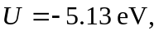 and
